18th August 2020

**The critical importance of engaging our customers in Covid secure practices: An open letter to the pub sector**

The impact of COVID-19 on the hospitality industry has been dramatic and far reaching. When we closed our doors in March, we had no idea how, or indeed if, we would weather this storm. Since then, together with other key industry bodies we have collaborated to ensure the collective voices and challenges of those we represent were taken to Government, leaving them in no doubt about the full impact of the pandemic on our sector and the support therefore required to sustain pubs through this period.

We believe that your hard work and dedication in ensuring you have reopened your businesses safely, both for your team members and your customers, along with the support packages that have been secured, has enabled a positive and welcome return to trading for the majority of pubs in recent weeks.

We have all independently surveyed our members to ensure we are aware of the challenges facing you at every stage, and we therefore know that one of the most important factors impacting business survival during this period continues to be Consumer Confidence. The Eat Out to Help Out (EOTHO) scheme has therefore been a real boost in encouraging nervous consumers to visit pubs and restaurants where they may have otherwise stayed at home.

Report data taken from the Yumpingo and CGA campaign “*We hear you*”, reveals that nearly 80% of consumers make their choice about which venue they will visit, based on the precautionary COVID-19 measures those businesses have put in place. Initial nervousness about venturing out to eat and drink is decreasing, with also 40% of customers visiting venues completely new to them. Engaging customers with clear communication on new layouts and ways of working is at the heart of their confidence and unfortunately some businesses are not hitting the expectations of their customers.

In the Customer Sentiment Tracker produced by KAM Media in association with Feed It Back, there has been a small but steady decline in the satisfaction felt by customers since reopening. Some venues however, continue to score very highly, showing that the right approach is winning consumers over. With initial confidence dwindling however, those not doing everything they can to reassure their customers with COVID-19 measures, could stand to lose out to those who are.

Proactively engaging all of your customers in our venues’ new ways of working has now clearly become a business critical issue. Without high levels of customer confidence supporting trade now and critically building momentum moving forward, we will not see the ongoing revenues that will be needed to sustain many of our venues.

Test & Trace is a key part of this. The vast majority of consumers are willing to give their contact details, yet there remains considerable variation from business to business around the procedures for how these details are taken. A robust procedure, not only enables the NHS to identify and quickly limit the spread of any COVID-19 outbreaks, but is also essential in underpinning continued consumer confidence in hospitality as a sector.

With face coverings mandatory in all other public areas from galleries and museums through to shops and public transport, it is vital that we play our part in keeping our customers safe with a specific emphasis on not only collecting customer details, but also ensuring that we only take bookings for a maximum of 2 households when seated indoors.

Whilst venues cannot categorically know this to be true, the responsibility remains with us as businesses to ask those questions, limit table sizes and understand the consequences for those not adhering to the guidance. As always, the majority are playing their part, but with recent reports of hospitality venues not asking for these basic details on arrival, the reality for our industry is that these guidelines will be significantly strengthened and may soon become mandatory in England, as with Wales and Scotland. Not explicitly delivering these requirements, will increasingly lead to a real risk of significant business disruption.

We recognise the many challenges that you are all facing and we are all here to fully support our members through this challenging period. At the heart of a successful recovery will be our collective ability to meet the expectations of our customers, both now and into the future, ensuring that we have sustainable businesses, providing the fantastic hospitality experience that we deliver so well.

**UKHospitality Chief Executive Kate Nicholls said:**

“There are many methods that can be used to collate the simple data required for Test & Trace, and we have seen widespread support from consumers when it comes to providing those details.

“We must come together as a sector to show how committed we are to ensuring the continued safety of our customers and teams, at a time where we are seeing a huge surge in customer numbers with customers taking advantage of the “Enjoy Summer Safely” campaign.”

**Emma McClarkin, Chief Executive of the BBPA said:**

“The Government has provided our sector with valuable financial support. It is our responsibility to prove that we can be relied upon to keep our customers safe with the measures that we have put in place. In the few cases identified by Test & Trace, our sector has reacted swiftly and efficiently to ensure the safety of everyone involved and proved that hospitality businesses have always been adept at dealing with health and safety within their venues. Ensuring details are collected across the board will be key to keeping our venues open and trading once we head into Autumn.”  
  
**Steven Alton, CEO of the BII said:**

“Since pubs have reopened, communities have started to come back to life again. We need to ensure we do all we can to protect our teams and customers and help prevent further lockdowns. Pubs are so much more than just places to eat and drink, and to lose the confidence of people to return to a space where they can come together and connect with each other could cause long term damage to the social fabric of our society.”

Yours sincerely,

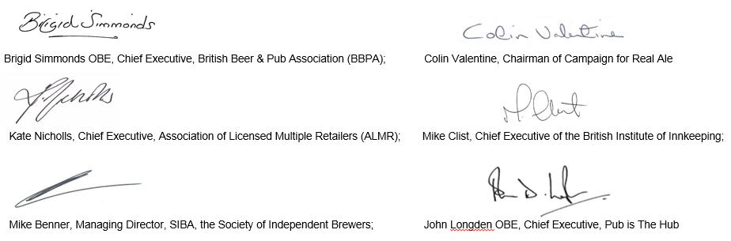

Kate Nicholls, CEO, UKHospitality

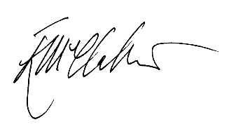

Emma McClarkin, Chief Executive, BBPA

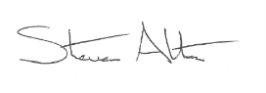

Steven Alton, CEO, BII